**Assets**

<https://www.farmers.co.nz/INTERSHOP/static/WFS/Farmers-Shop-Site/-/Farmers-Shop/en_NZ/product/63/93/779/1/6393779_00_W460_H600.jpg>

<https://images-na.ssl-images-amazon.com/images/I/71j45SkG7kL._SX569_.jpg>

**https://images.autods.com/ebay_images/19663-Pedigree-Junior-Dry-Dog-Food-for-Young-Medium-Dogs-and-Puppies-212-Months-with-Chicken-and-Rice-1-Bag-1-x-10-kg-aaae8922-6b9c-4315-9369-39ee0147f502**

**Assignment Brief**

Pet Planet is a pet shop located in High Street, Ashford. It is a family business run by the Ellis family: father, mother, son and daughter. They set up the business some 20 years ago but now feel they need to reach more customers and would like to do this by going online. They do not want to sell products online yet but would like to show some of what they have available.

The website should meet the following requirements:

* There should be a mixture of text and images on each page
* There should be three pages as follows:
  + Home page with contact information for the business
  + A products page showing pet care products and accessories that they stock
  + A page about how to care for pets. This should cover the most common pets eg cats, dogs and one other.
* They would like you to develop a house style for them, including a logo, colour scheme and font styles.

**Tasks**

1. Create a visualisation diagram for the home page.
2. Create a moodboard to show the colour schemes and general feel of the website.
3. Collect assets and store them in a folder. Assets are any images, videos or sounds that you will use on your web pages. Make sure you know where you get them from eg from a web site (not Google – what is the web address where the images etc are stored?).
4. 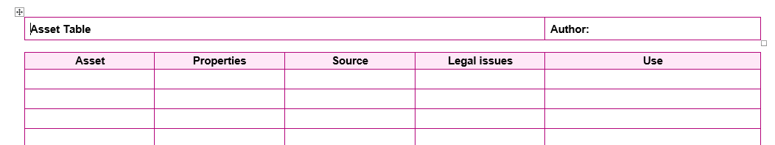Make an assets table that looks like this:
5. Create a simple logo for the business.
6. Create a home page and a style sheet.
7. Copy the home page and change the content to create the other two pages.
8. Create a test table that looks like this:

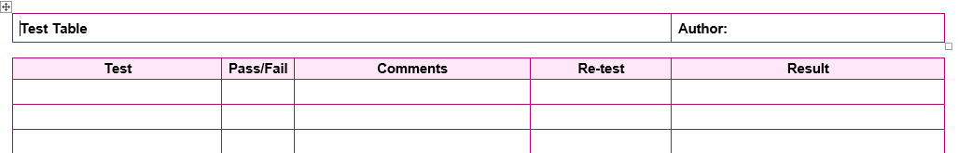

Test all the functionality of your web pages. Some of the things you should include are:

whether the pages open properly  
images are correctly displayed  
text is correctly displayed  
house style

1. Evaluate your finished work against the clients’ requirements listed above. Which of the requirements have you met? How? Have you partially met some of them? Explain why. Which requirements have you not met? Explain these and say why. What could you do to improve the web pages in the future if you had more time? Would these improvements help to meet the client’s requirements even further?